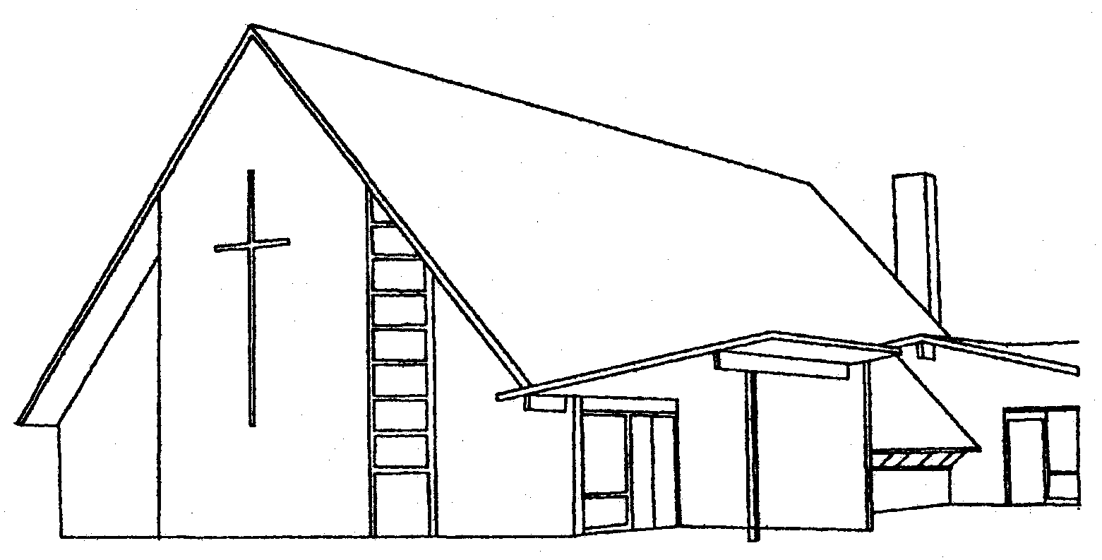
Niantic Community Church
United Church of Christ / United Methodist
An Open, Affirming, and Reconciling Congregation • A Heritage of Faith since 1719

“Each Member A Minister” www.nianticcommunitychurch.org
170 Pennsylvania Avenue • Niantic, CT 06357
phone: 860-739-6208 • fax: 860-739-8308

Dear applicant:
Thank you for applying for a NCC grant-please be aware of the conditions of this program
- This is limited to NCC members and their children only.
- This is a grant and does not have to be repaid.
- Applications are due by June 30 and include the grant application form and an essay. Applicants from previous years need not include another essay.
In 300 or fewer words please write an essay on either of these topics
  - How do you think your education will help you give back to the community?
  - How did your time at Niantic Community Church influence your career/education choice?
- Amount of grant will be determined yearly and will be based on number of applicants and amount of money available in the NCC Memorial Education Fund.
- You must apply yearly.
- Grants will be given out in August. The check will be made out to you and it will be mailed to the home address on your application.
- You must plan to take at least 12 credits (or 3⁄4 of a workload if your school does not administer credits).
- You may receive up to:
Four grants while earning a bachelor’s degree
Two grants for an associate’s degree
One or two grants for technical/trade school dependent upon length of program

THE NCC MEMORIAL COMMITTEE GRANT APPLICATION
All information furnished on this application will be treated as confidential by this committee
PRINT ALL INFORMATION
Last Name:___________________ First Name____________ Mid. Init_______
Street Address______________________________ City/town______________
State______ Zip Code________
Email address:_________________________________

Are you (or are your parents) a member of Niantic Community Church?

What school will you be attending:

What is your planned major or likely area of study:

My signature indicates that I have included each of the items indicated above and I am returning all enclosures by June 30
Parent/Guardian’s Printed Name __________________________________

Parent/Guardian’s Signature _____________________________________

Students Printed Name _________________________________________

Student’s Signature ____________________________________________

Revised October 2023

